**Assignment :**

Create an IAM user using Cloud-Formation and Terraform with the following conditions:

1. It should have Lambda Full Access
2. S3 Read only access
3. Cloud-Watch read only access

**Solution :**

**(a.)Using Cloud-Formation**

JSON file is there in the folder Here are some screenshots:

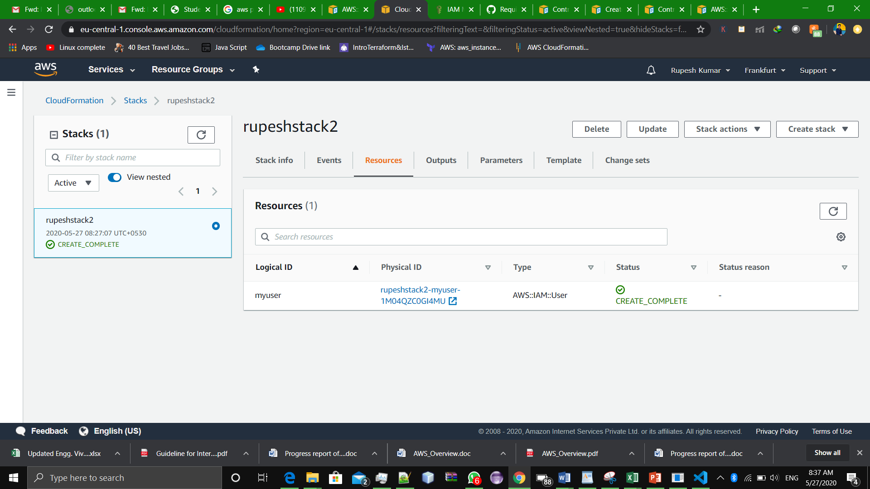Stack being Created.

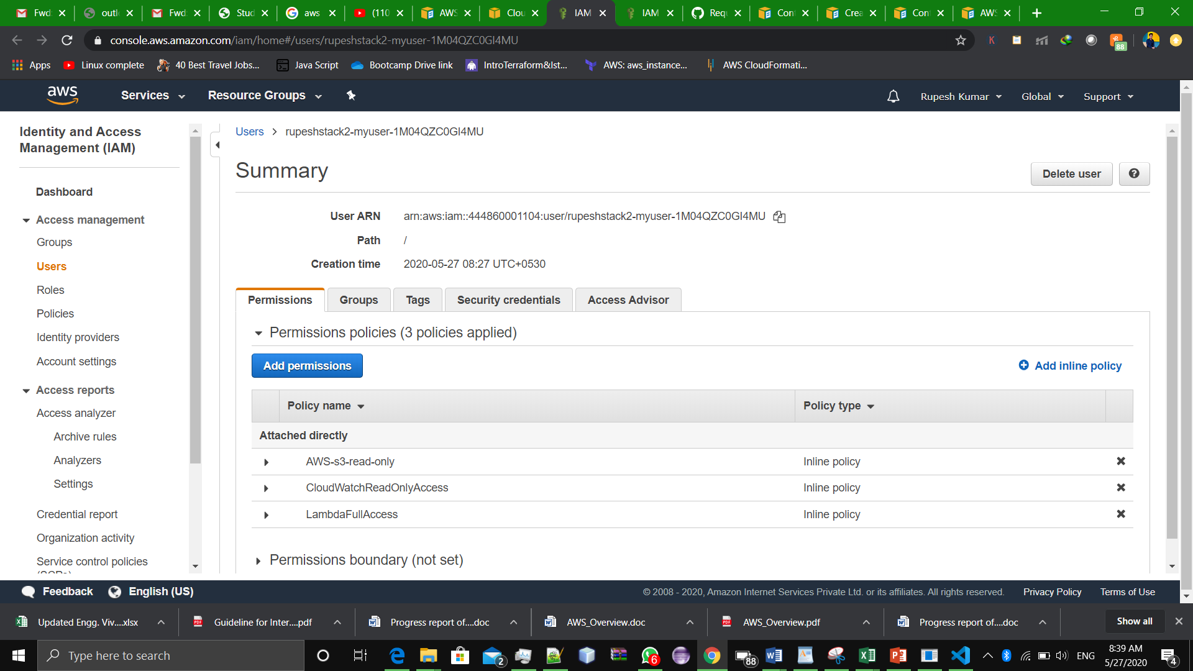IAM user with following permissions being created.

**(b.)Using Terraform**

.tf file is there in the folder, here are some screenshots:

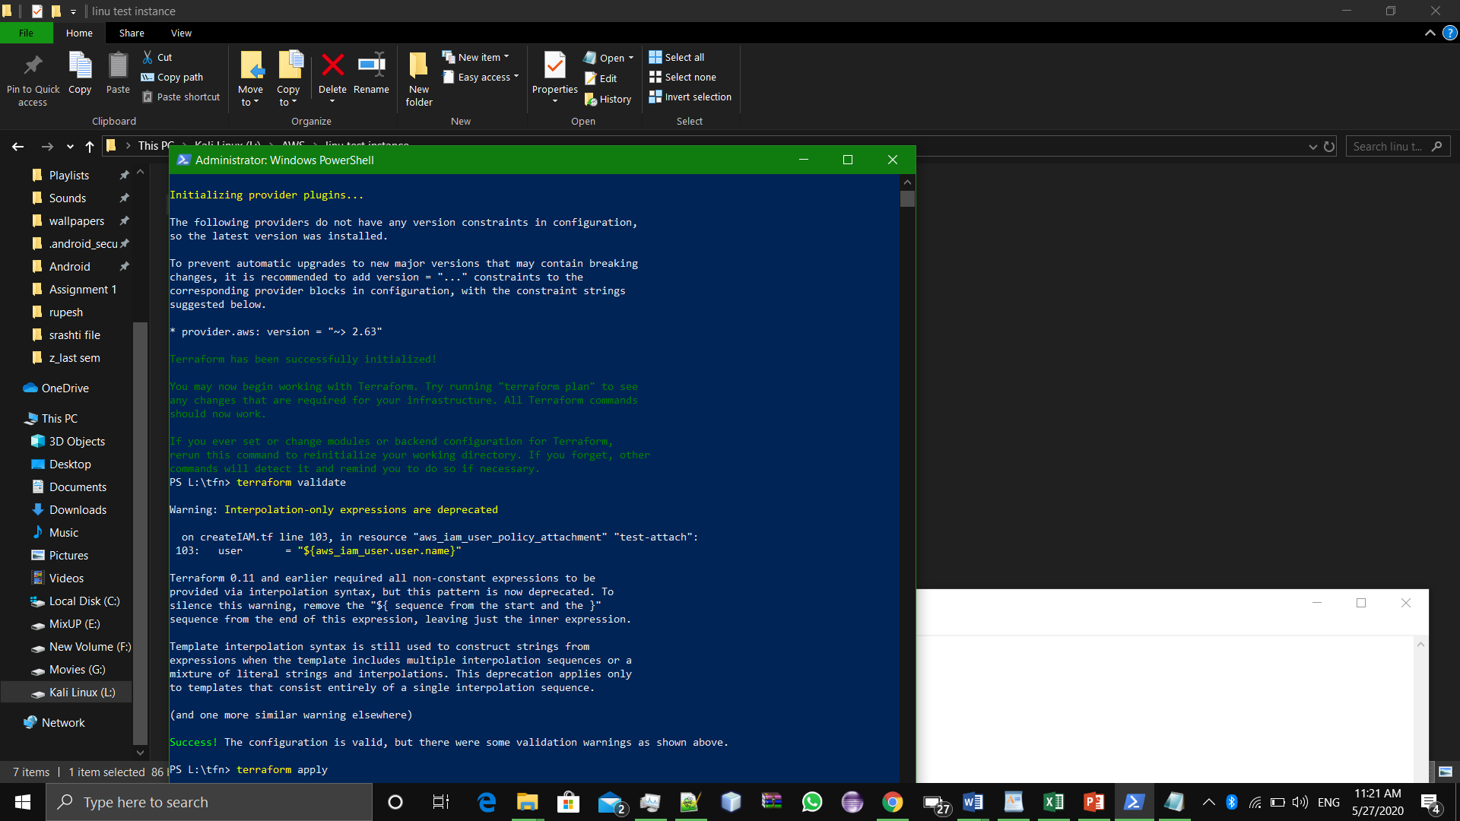

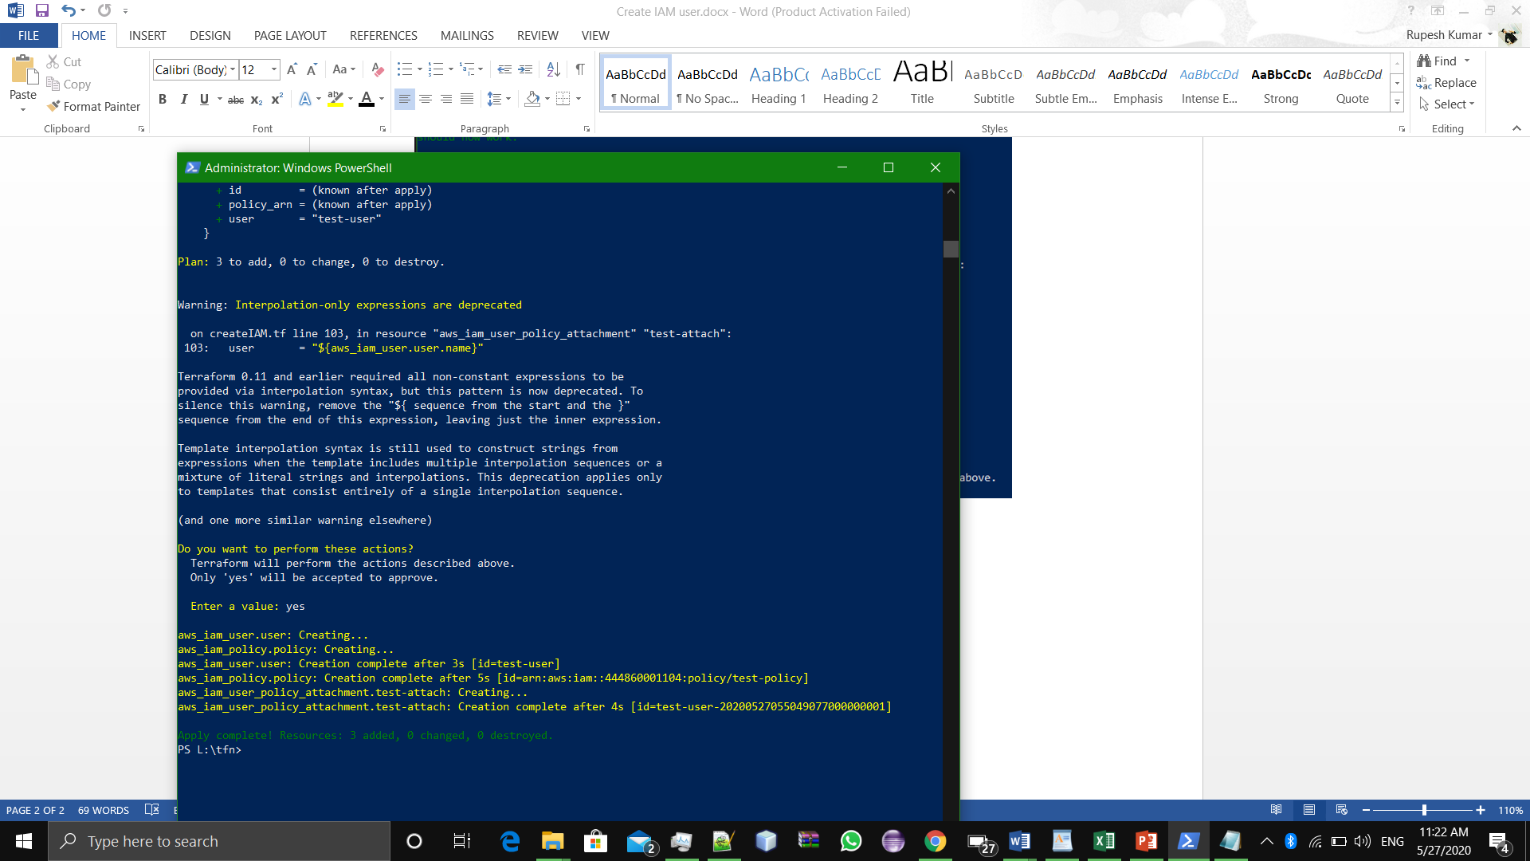

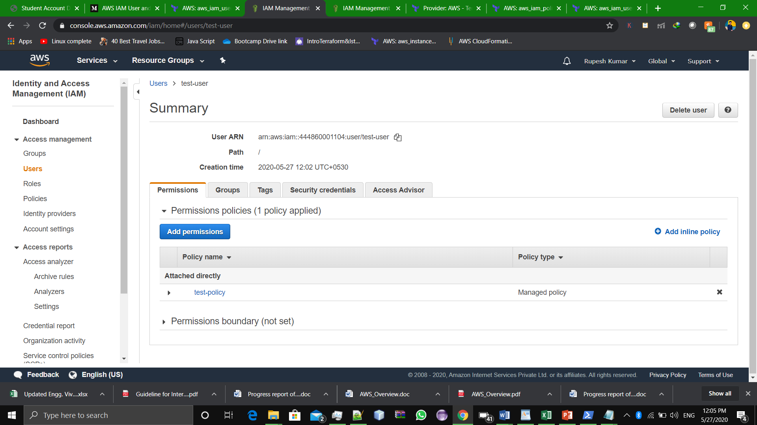

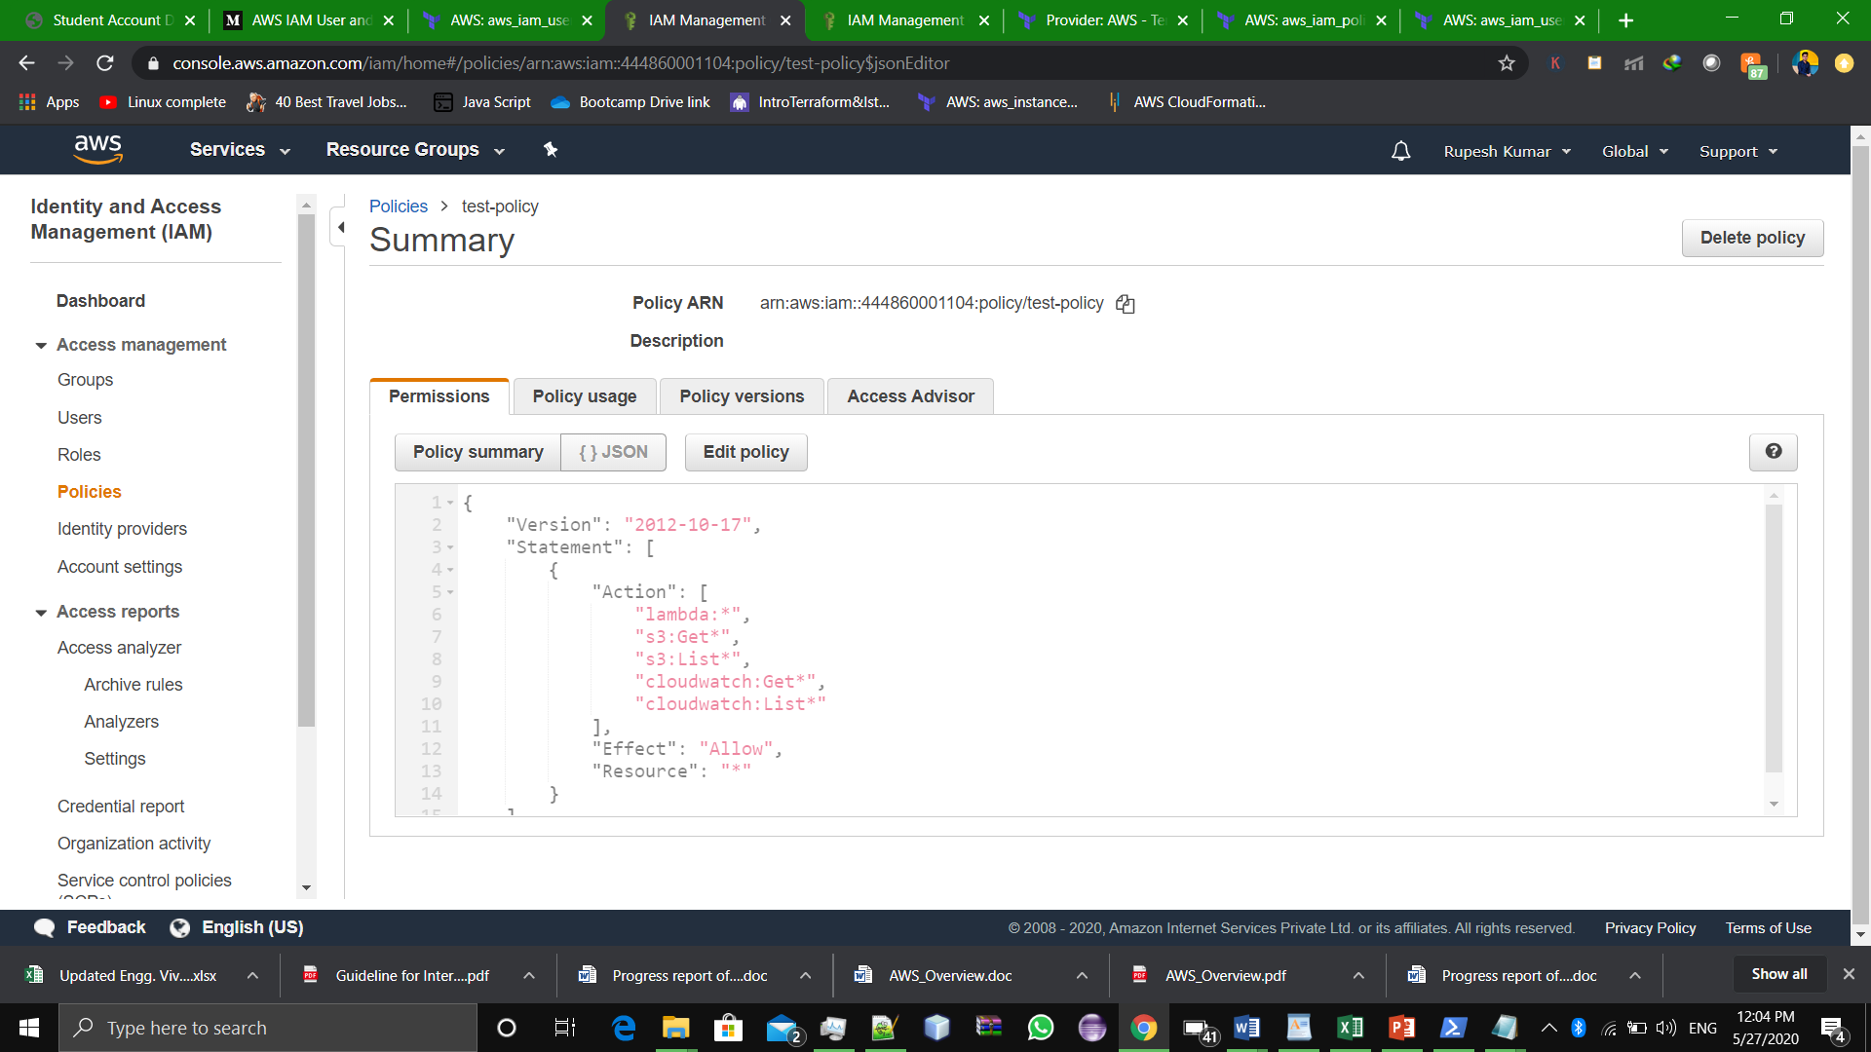#Assignment Completed